Experiment 8: Scaling an Image to Bigger and Smaller Sizes
Software / Tools: Python · OpenCV (cv2)

AIM
To resize (scale) an image to a larger size and a smaller size using OpenCV.
ALGORITHM
1. Import OpenCV.
2. Read the input image.
3. Use cv2.resize() with fx, fy > 1 (e.g. 1.6) and INTER_LINEAR interpolation to enlarge.
4. Use cv2.resize() with fx, fy < 1 (e.g. 0.5) and INTER_AREA interpolation to shrink.
5. Display and save both resized images alongside the original.
PROGRAM (SOURCE CODE)
import cv2

img = cv2.imread("image.jpg")

# Bigger (1.6x)
bigger = cv2.resize(img, None, fx=1.6, fy=1.6, interpolation=cv2.INTER_LINEAR)

# Smaller (0.5x)
smaller = cv2.resize(img, None, fx=0.5, fy=0.5, interpolation=cv2.INTER_AREA)

cv2.imshow("Original", img)
cv2.imshow("Bigger", bigger)
cv2.imshow("Smaller", smaller)
cv2.waitKey(0)
cv2.destroyAllWindows()

OUTPUT
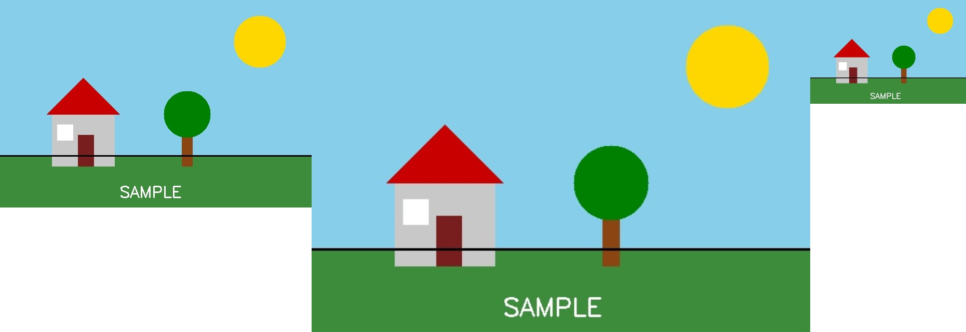
Fig. 8 — Output of Experiment 8: Scaling an Image to Bigger and Smaller Sizes.
RESULT
Resize (scale) an image to a larger size and a smaller size using OpenCV — completed successfully, as demonstrated in the output shown above.

